Chapter 3, Problem 52.

Use mesh analysis to find i₁, i₂, and i₃ in the circuit of Fig. 3.97.

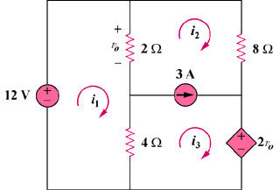

Figure 3.97
For Prob. 3.52.

